1. Text

   Description automatically generated
2. The above scenario is to serve two purposes.
   1. How to dockerize and run a console app.
   2. How to attach such app to interact with the app as the above app takes two console integer inputs.
3. Let’s create Dockerfile
   1. Text

      Description automatically generated
   2. Graphical user interface, text

      Description automatically generated
4. 
5. Text

   Description automatically generated  
   From the Lecture 29, we know that when running container with run command, the command prompt is attached to process of the container and so we can see output (log) from the process but we’re not able to interact with the process (Like you want to give input but not able).
6. Let’s run the docker –help to see useful option.
   1. options:
      1. -i:
         1. 
         2. To launch a container in inactive mode.
      2. -t:
         1.   
            In the end, it means terminal.
   2. So basically, with these two options, we get a terminal in interactive mode.
7. 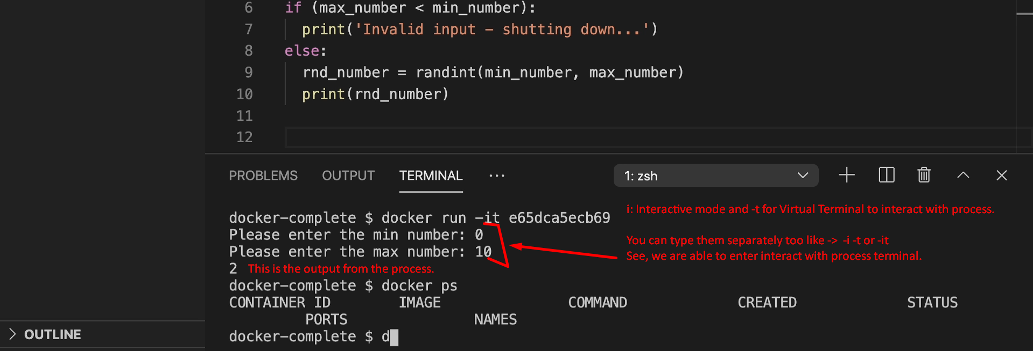
8. Now, the question is how to restart a container in interactive mode?
   1. First Try:
      1. 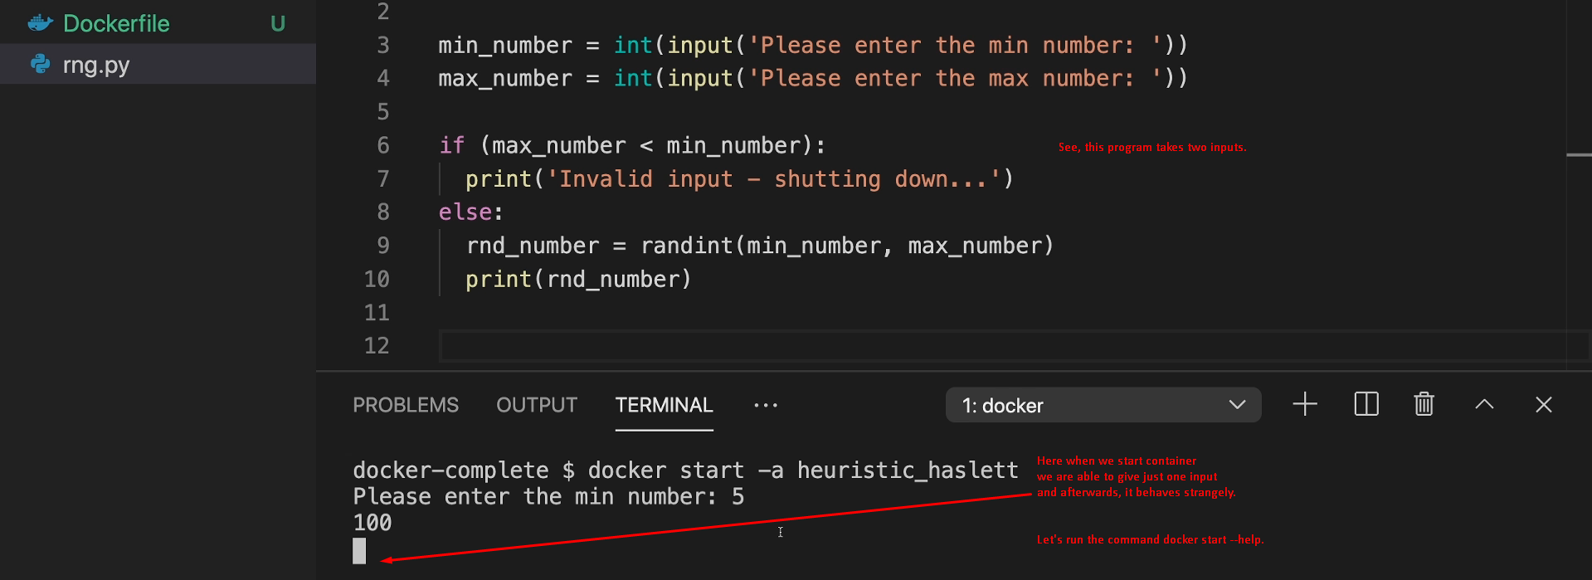  
         A picture containing text

         Description automatically generated
   2. Second Try:
      1. 
9. So, docker is not just about Web apps, Long running apps but utility app like this where we need to give some input and output is spit on the console.